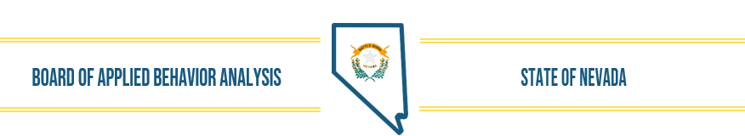
NOTICE OF PUBLIC MEETING
Applied Behavior Analysis BOARD MEETING
Date of Posting: January 9, 2024
Date and Time of Meeting: January 16, 2024, 10 AM

Name of Organization: Nevada Applied Behavior Analysis Board

Place of Meeting: Teleconference and NV ABA Office-
6170 Mae Anne Ave. #1 Reno, NV

Please place your phone or your computer microphone on mute unless providing public comment.

Join Zoom Meeting
https://zoom.us/j/98608434207?pwd=aXpZZVcwYnZ5eGxlWjRTWmdNMktTQT09
Meeting ID: 986 0843 4207
Passcode: 419314
Dial by your location
• +1 669 444 9171 US
• +1 669 900 9128 US
Meeting ID: 986 0843 4207
Passcode: 419314
Find your local number: https://zoom.us/u/auXf89y6B

Please Note: The Applied Behavior Analysis Board (ABAB) may (1) address agenda items out of sequence to accommodate persons appearing before the Board or to aid the efficiency or effectiveness of the meeting; (2) combine items for consideration by the public body; and (3) pull or remove items from the agenda at any time. The Board may convene in closed session to consider the character, alleged misconduct, professional competence or physical or mental health of a person. See NRS 241.030. Prior to the commencement and conclusion of a contested case or a quasi-judicial proceeding that may affect the due process rights of an individual the board may refuse to consider public comment. See NRS 233B.126. At the discretion of the Chair, public comment is welcomed by the Board, but will be limited to three (3) minutes per person. A public comment time will be available at the beginning of the meeting and then once again prior to adjournment of the meeting. The Chair may allow additional time to be given a speaker as time allows and in his/her sole discretion. Once all items on the agenda are completed the meeting will adjourn.
Nevada Applied Behavior Analysis Board Board Meeting Agenda January 16, 2024
- Call to Order, Roll Call of Members, and Establish Quorum

- Public Comment
(No action may be taken upon a matter raised under public comment period unless the matter itself has been specifically included on the agenda as an item. Comments will be limited to three minutes per person. People making comments will be asked to begin by stating their name for the record and to spell their last name and provide the secretary with written comments. Persons wanting to make comments during public comment period, now or in a later public comment period, can participate via the Zoom link or by telephone by calling 1-669-900-9128. Please note these links and numbers change for each meeting.)

- Approval of December 19, 2023 Board Meeting Minutes (For possible Action) (attachment)
- Election of Officers-
  - President
  - Secretary/Treasurer

- Executive Director’s Report
- Legislative Update (For Possible Action)

- Review, Discussion, and Possible Approval of Board Activities (For Possible Action)
Mission Statement – review/approve
NRS/NAC review- Next steps
NAC 641D proposed regulations- review/approve

- Complaints

- Financial Update (For Possible Action)
Financial reports December 2023
Financial Audit

- Discussion of Current Status of Applications and other Licensing Activities (For Possible Action)
Licensed/Registered individuals without Federal background clearance
Certemy Contract/agreement ends 6/2024
Licenses/Registrations/Renewals issued in December/Yearly totals and to-date January

- Determine Future Agenda Items (For Possible Action)
- Public Comment
(No action may be taken upon a matter raised under public comment period unless the matter itself has been specifically included on an agenda as an action item. Comments will be limited to three minutes per person. Persons making comment will be asked to begin by stating their name for the record and to spell their last name and provide the secretary with written comments.)

- Adjournment

NOTE: We are pleased to make reasonable accommodations for members of the public who have disabilities and wish to attend the meeting. If special arrangements for the meeting are necessary, please notify Wendy Knorr at (775-746-9429) as soon as possible and at least one business day in advance of the meeting. If you wish, you may e-mail her at executivedirector@nvababoard.org. Supporting materials for this meeting are available at 6170 MaeAnne Ave., Suite 1, Reno, NV 89523 or by contacting Wendy Knorr at 775-746-9429, or by email executivedirector@nvababoard.org. Agenda and supporting materials posted at these locations and online on the following sites: https://notice.nv.gov/ www.nvababoard.org and NVABA Office.

